**Name:Sreelakshmi R**

**RollNo:41**

**Batch: MCA**

**Date : 3-06-2022**

EXPERIMENTNO:8

AIM:

**Perform CRUD Opertions**

**PROCEDURE:**

**1.CREATE**

use databasename : To create Database.

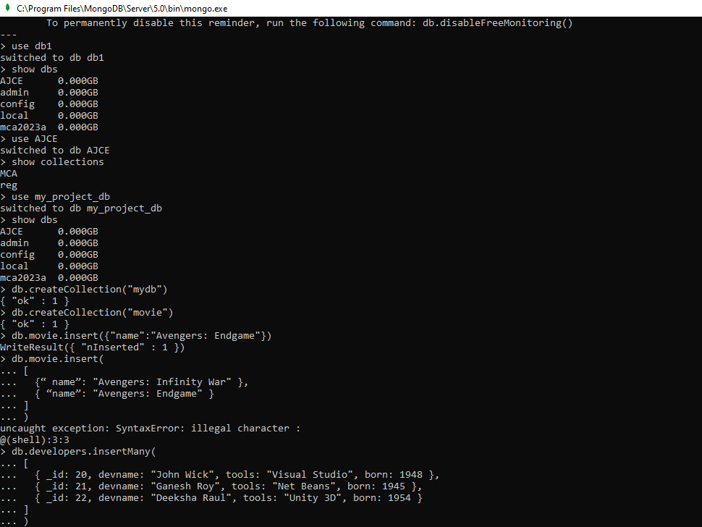

show dbs :Listing All Databases.



db.createCollection: Creating Collections(Tables).

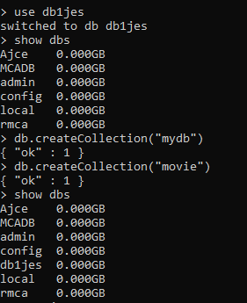

show Collections :To show Collections.

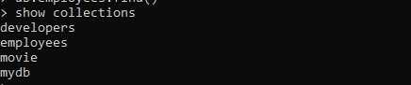

Insert():Inserting Values to Collection

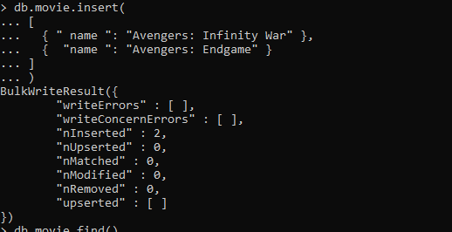

InsertMany():

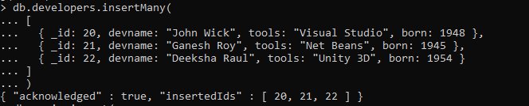

**2.READ**

Find():

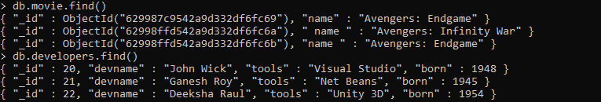

**3.UPDATE**

Update();

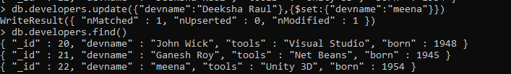

UpdateMany();

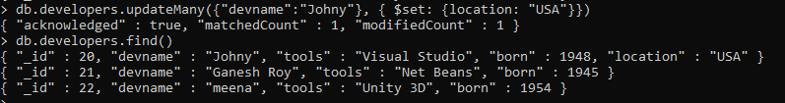

**4.DELETE**

DeleteOne():

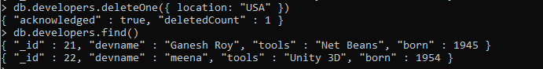

DeleteMany():

